1.1P: Preparing for OOP – Answer Sheet

1. Explain the following terminal instructions:
   1. cd: change directory
   2. ls: listing directory
   3. pwd: print working directory
2. Consider the following kinds of information, and suggest the most appropriate data type to store or represent each:

| Information | Suggested Data Type |
| --- | --- |
| A person’s name | String |
| A person’s age in years | Integer |
| A phone number | String |
| A temperature in Celsius | Float |
| The average age of a group of people | Float |
| Whether a person has eaten lunch | Boolean |

1. Aside from the examples already provided in question 2, come up with an example of information that could be stored as:

| Data type | Suggested Information |
| --- | --- |
| String | Addresses, Location,... |
| Integer | Number of people |
| Float | Average number of anything |
| Boolean | Conditional |

1. Fill out the following table, evaluating the value of each expression and identifying the data type the value is most likely to be:

| Expression | Given | Value | Data Type |
| --- | --- | --- | --- |
| 6 |  | 6 | Integer |
| True |  | True | Boolean |
| a | a = 2.5 | 2.5 | Float |
| 1 + 2 * 3 |  | 7 | Integer |
| a and False | a = True | False | Boolean |
| a or False | a = True | True | Boolean |
| a + b | a = 1  b = 2 | 3 | Integer |
| 2 * a | a = 3 | 6 | Integer |
| a * 2 + b | a = 2.5 b = 2 | 7 | Integer |
| a + 2 * b | a = 2.5  b = 2 | 6.5 | Float |
| (a + b) * c | a = 1  b = 1  c = 5 | 10 | Integer |
| “Fred” + “ Smith” |  | Fred Smith | String |
| a + “ Smith” | a = “Wilma” | Wilma Smith | String |

1. Using an example, explain the difference between **declaring** and **initialising** a variable.

The difference between the two is declaring only provide basic attributes but initializing provides details of a variable.

1. Explain the term **parameter**. Write some code that demonstrates a simple of use of a parameter. You should show a procedure or function that uses a parameter, and how you would call that procedure or function.

A parameter is the variable listed inside the parentheses in a function definition  
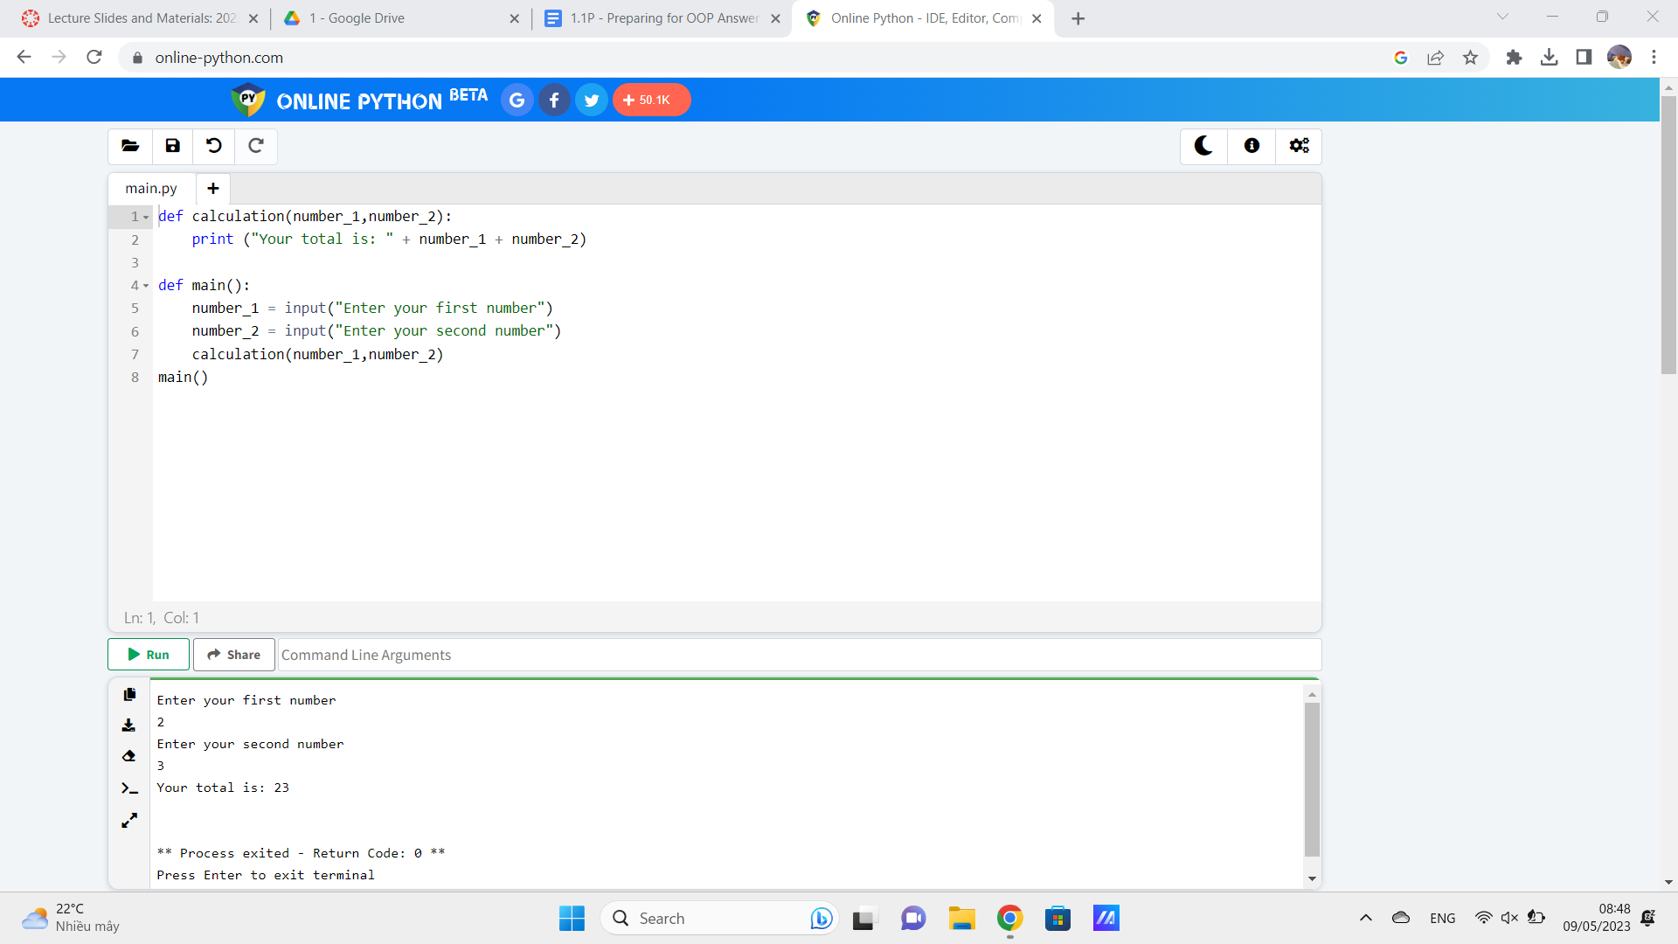

1. Using an example, describe the term **scope**.

Scope is the location in a program where a name is visible and accessible

1. In any procedural language you like, write a function called Average, which accepts an array of integers and returns the average of those integers. Do not use any libraries for calculating the average. You must demonstrate appropriate use of parameters, returning and assigning values, and use of a loop. Note — just write the function at this point, we’ll *use* it in the next task. You shouldn’t have a complete program or even code that outputs anything yet at the end of this question.

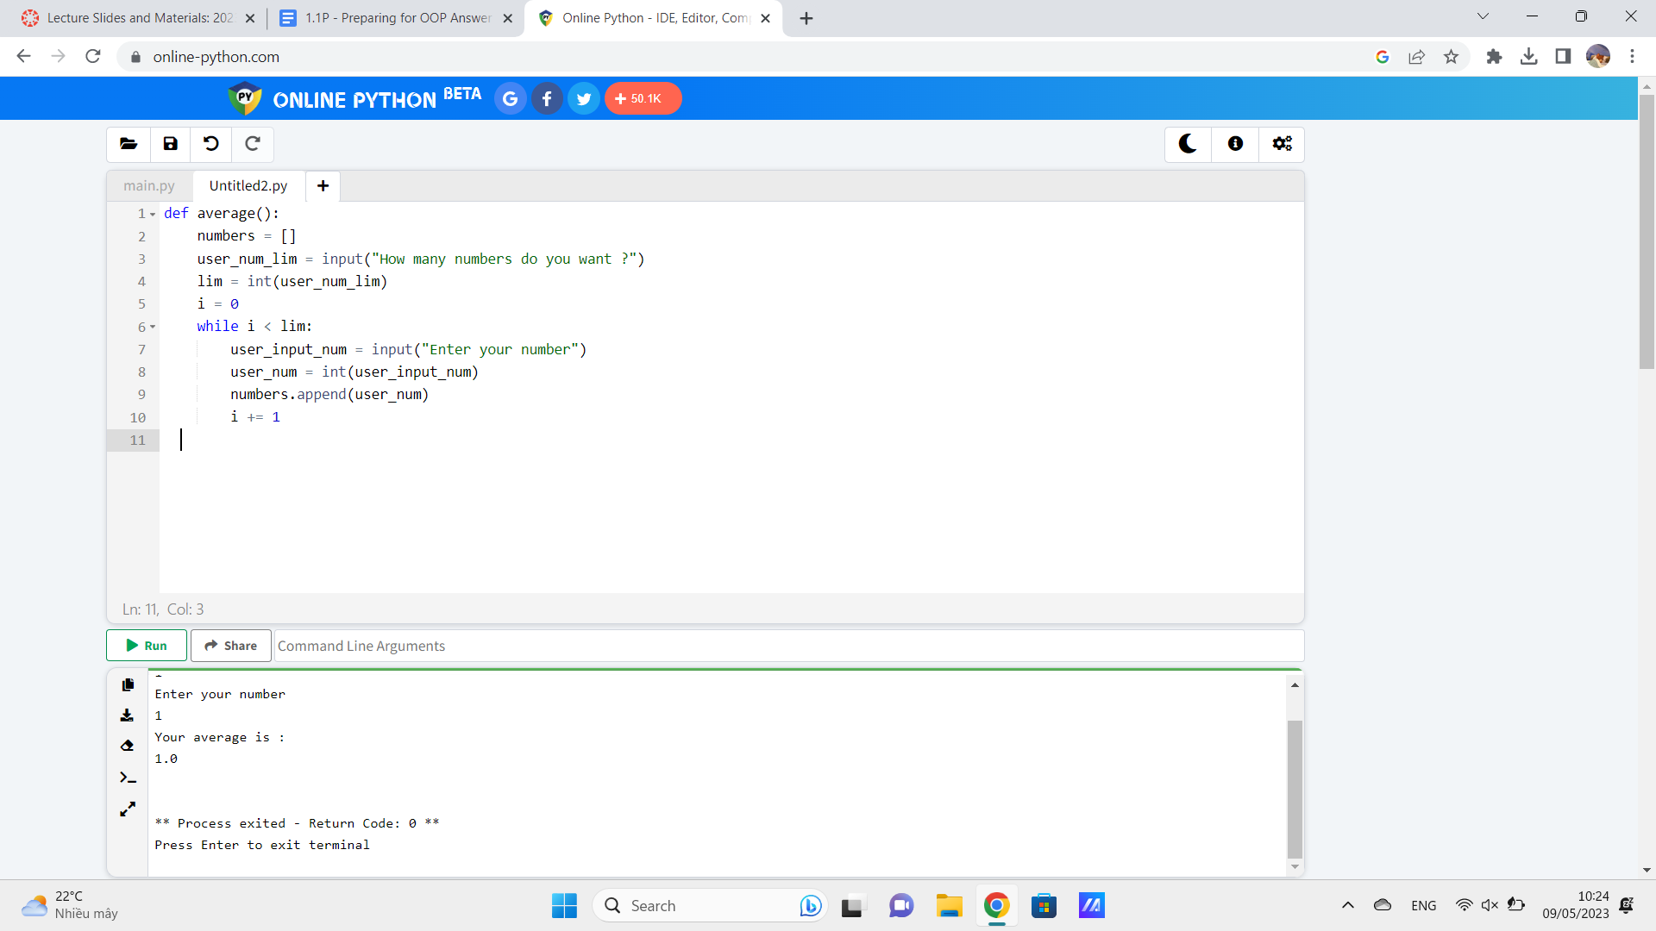

*<insert a screenshot of your code here>*

1. In the same language, write the code you would need to call that function and print out the result.

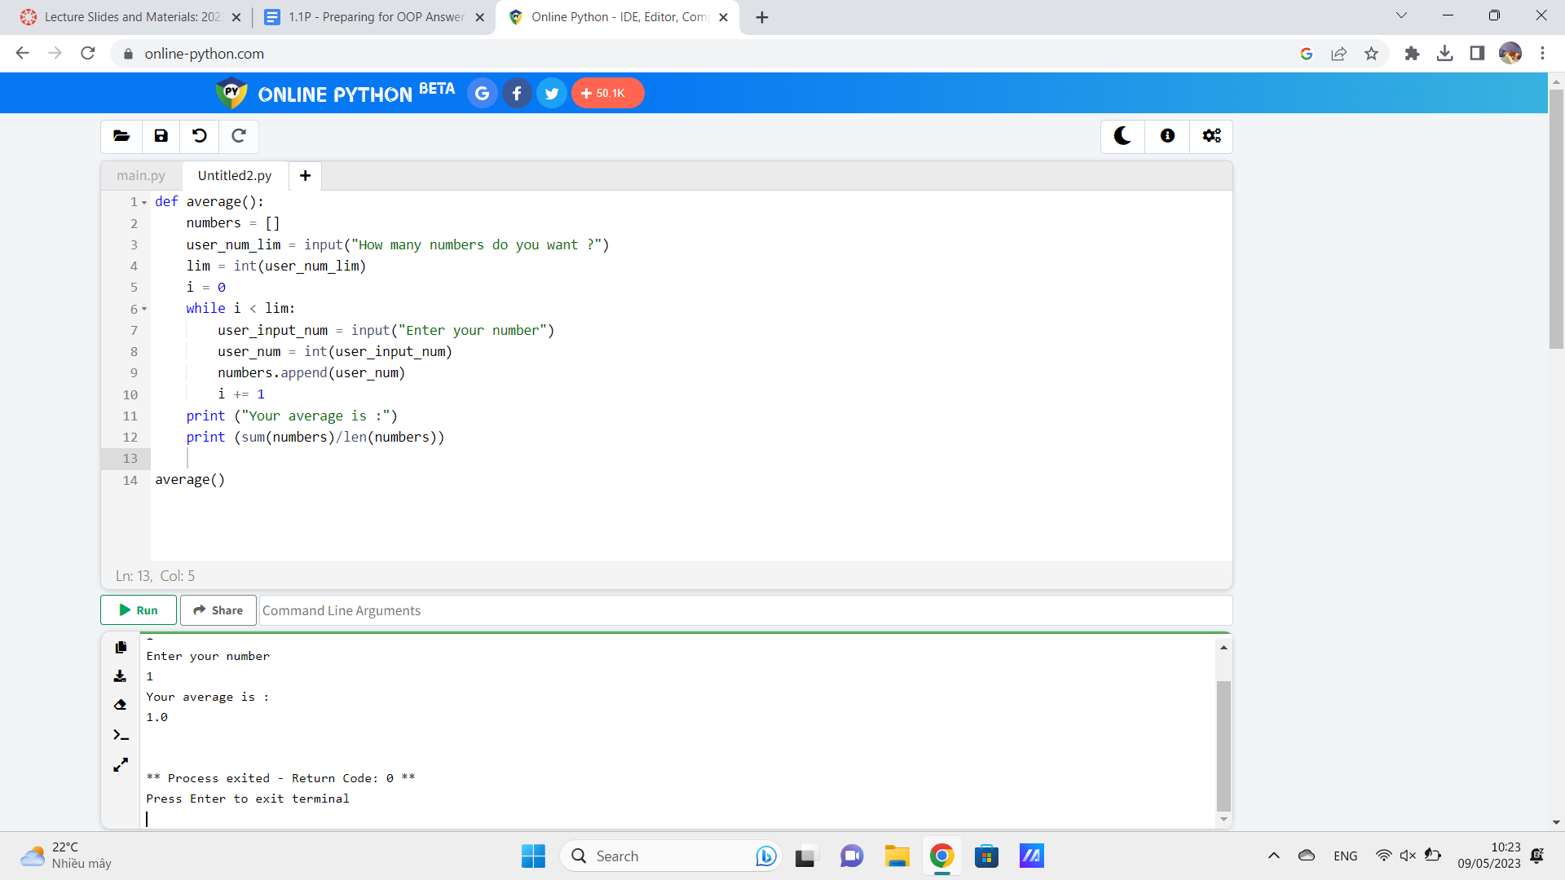

*<insert a screenshot of your code here>*

1. To the code from 9, add code to print the message “Double digits” if the average is above or equal to 10. Otherwise, print the message “Single digits”. Provide a screenshot of your program running.

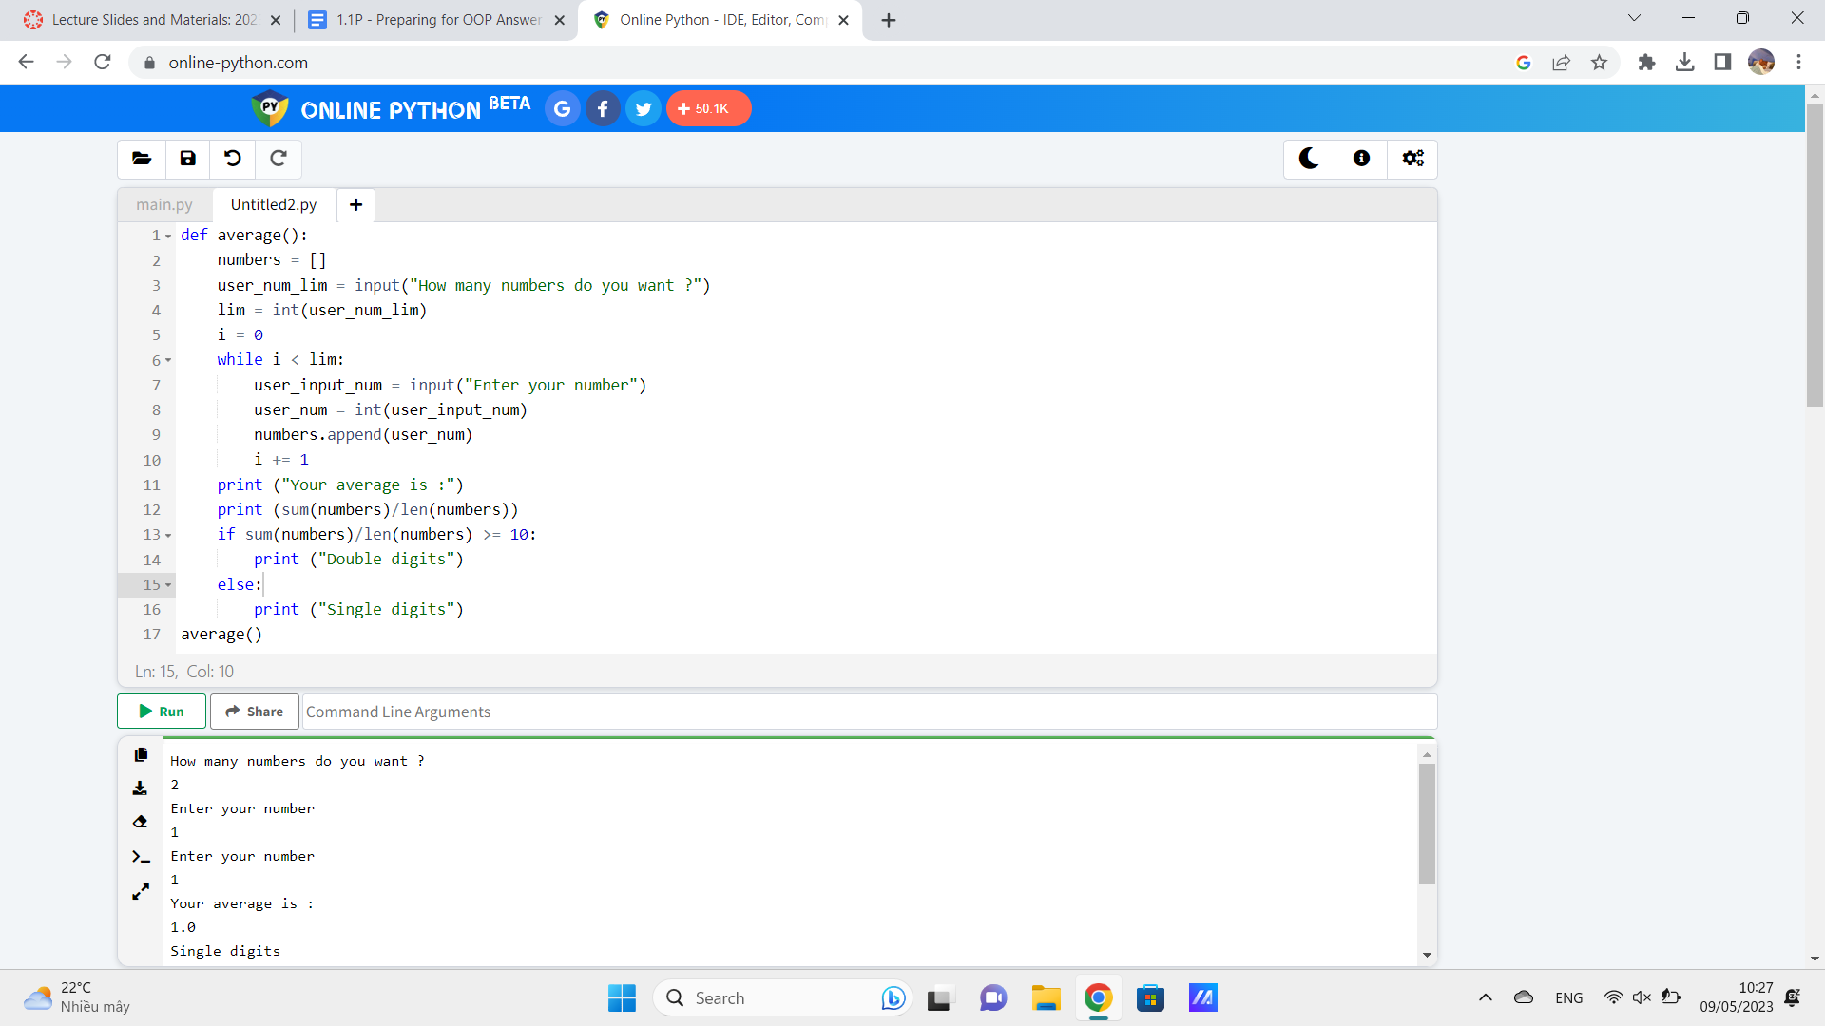

*<insert a screenshot of your code here>  
  
<insert a screenshot of your whole program running here>*

